DESIGN-ATHON

PROBLEM STATEMENT:

Now-a-days job search has become a tough thing because the candidate has to go through so many steps to get his dream job, they don’t have proper connections and Although an unsuccessful job search can be frustrating, accepting any old job or giving up altogether and consoling themselves with tub of ice cream isn’t the answer. Even it’s often hard for their CV to reach the hands of the qualified recruiter and also they have to submit their resumes in different companies by visiting each and every company and this may be time consumable and also after visiting a particular company for the job some people rely to work in that due to the low salary and after doing all that people may lose their confidence. So, they need an online based job search website/app in which they can post all their qualifications and get their dream job. And this platform will be helpful to Companies as well because it won’t require them to go and conduct interview in each and every college . they can just upload the job vacancy here and can select suitable candidate.

PROPOSED SOLUTION:

For that particular problem statement, we designed a platform which connects multiple organizational stake holders to help students find matching jobs for their profile.

Here Organizations create profiles, post their jobs, internships and hire on the platform and even the placement officers register and maintain their college profiles. A student can register in the website and can find the matching jobs for their profiles. In that they can upload all their qualifications CV and resume so, that they can select their matching jobs and companies can recruit them easily through this platform. This may be helpful for many students who are searching for their dream jobs.

CONTENT:

1.JOBS:

This section includes the display of various jobs which different organizers upload the vacancies in their organization. The user i.e. the person who search the job can check the salary, location of job, the qualifications required for the job & his position in the company.



The user can easily search their relevant job by selecting their required package per annum, location of job & career sector of the job.



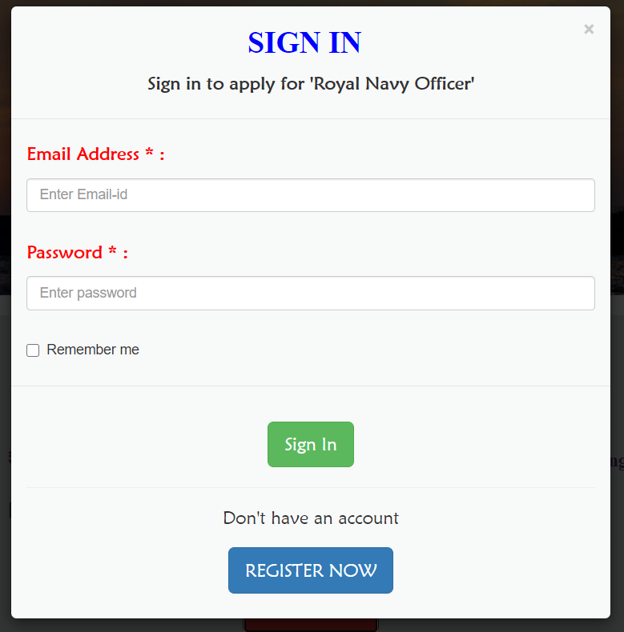

The details filled by the user will be sent to that particular organization & they will finalize the decision.

2.INTERNSHIPS

The internship section is same as of the job section, but the difference is the jobs which are available under the internship section are part time jobs.



3.EMPLOYER PROFILE’S:

The employer profile section is designed in such a way that it would provide information to the applicant regarding the company details. This section will showcase all the companies which are co-operating with this particular platform. The candidate can apply from that page to his/her dream company by clicking the SELECT Button. The below image is an extract of the Employer profile Page.

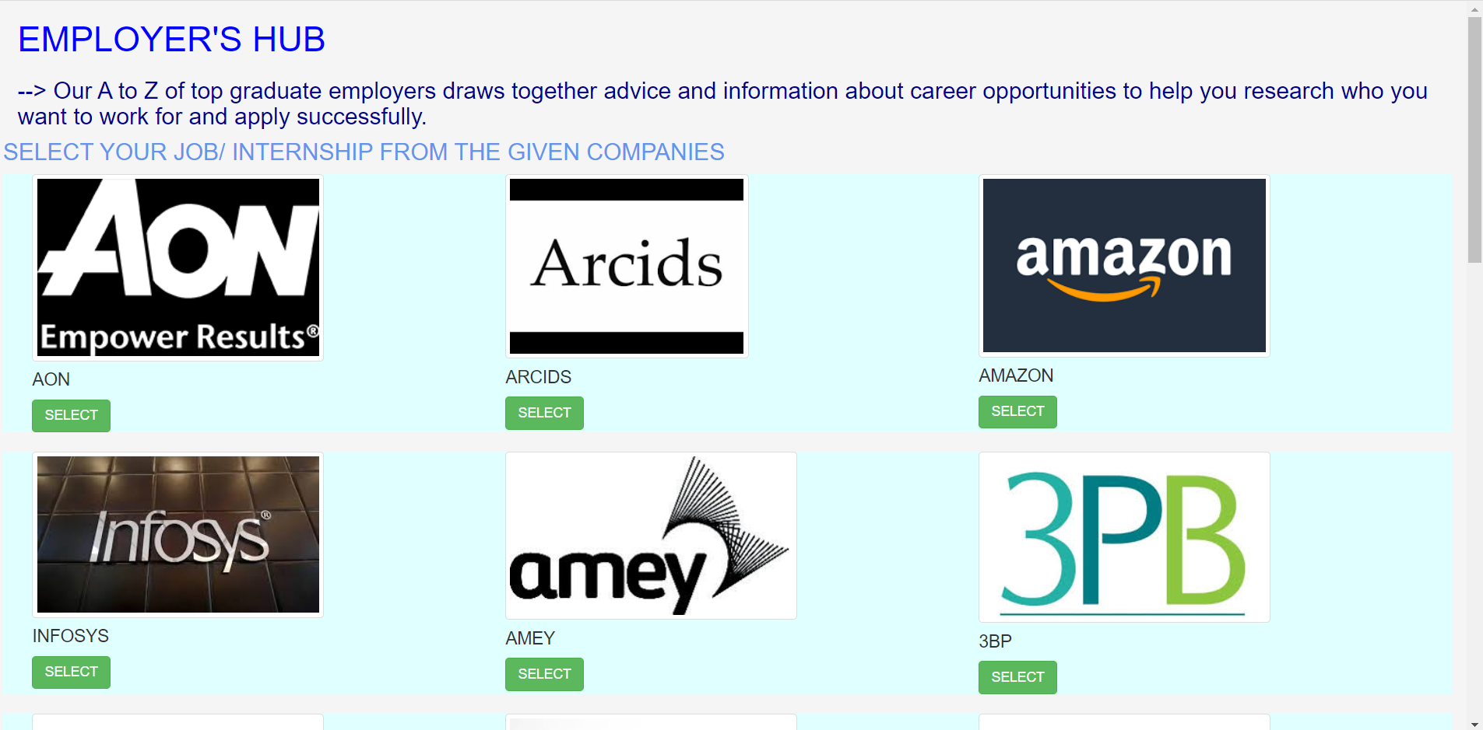

So, basically this sector will help the candidates to easily select their dream company and they need not to apply to all (unnecessary) company.

4.JOB SECTOR

In Job Sector page the candidates are exposed to all different possible sector for their job or Internship. In this section the candidate can select any sector. the below pic shows few examples of the job sectors in this page.

This sector not only provide the different option for graduate for their job, but if suppose they need further information regarding that sector, they can easily access by just clicking on that particular sector. In this way it would be very helpful to candidates to decide which sector they should apply or they are interested in. In this way this sector is going to be very helpful to the candidates in making their future decision. Like as shown below



5.EVENTS:

The Events sector in this web page is designed so, as to provide information regarding all the Events which has already conducted or will be conducted in the future. So, it will help the candidates to keep themselves updated about all the Events happening in the site.

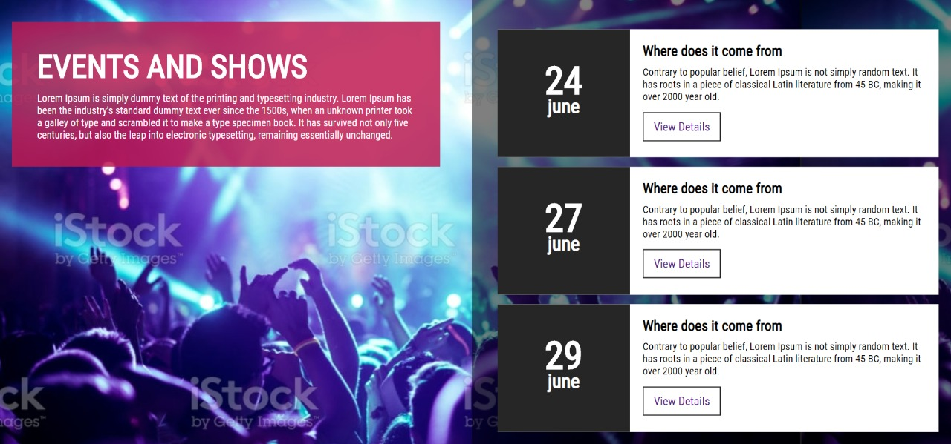

6.POST A JOB:

Apply job is the section of our platform where the organisation’s can create their own profile and add the jobs available in their company. The organisation can post the vacancy post in their organisation and then the candidates can apply for job/internship accordingly.

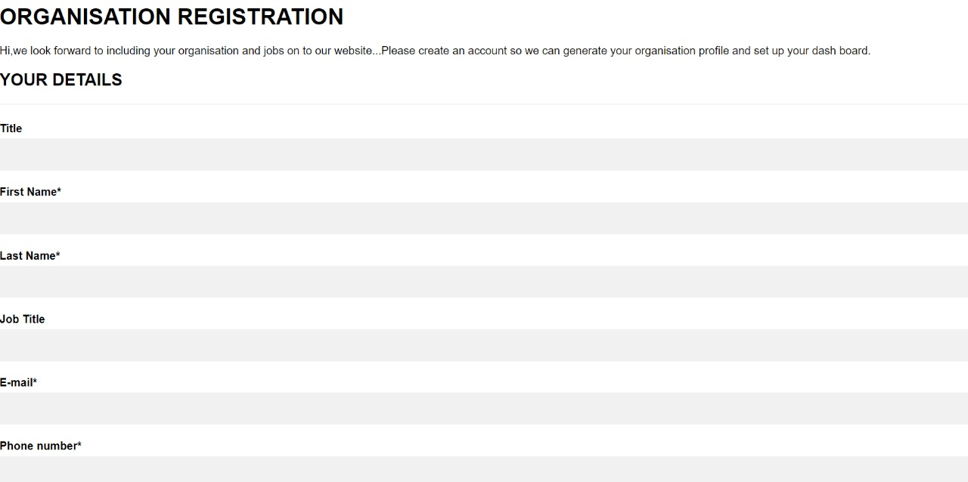

CODES:

1.HTML CODE FOR HOME PAGE

<!DOCTYPE html>

<html>

<head>

<title>HOME PAGE</title>

<link rel="stylesheet" type="text/css" href="style2.css">

<link href='http://fonts.googleapis.com/css?family=Montserrat:400,700%7CPT+Serif:400,700,400italic'

rel='stylesheet'>

<link href='https://fonts.googleapis.com/css?family=Montserrat|Open=Sans".rel="stylesheet"'>

</head>

<body>

<div class="bgimage">

<div class="menu">

<div class="leftmenu">

<h3>FIND DREAM JOB</h3>

</div>

<div class="rightmenu">

<ul>

<li class="active"><a href="homee.html" style="color: red">Home</a></li>

<li><a href="jobs.html" style="color: red">Jobs</a></li>

<li><a href="internship.html" style="color: red">Internship</a></li>

<li><a href="employee profile.html" style="color: red">Employer Profiles</a></li>

<li><a href="job sector.html" style="color: red">Job sectors</a></li>

<li><a href="index.html" style="color: red">Events</a></li>

</ul>

</div>

</div>

<div class="text">

<h1 style="color: red">FIND YOUR DREAM JOB</h1>

<h2>Did you know that members with full profiles are more likely </h2>

<h2>to get direct messages from employers?</h2>

<h2>Don't miss this great opportunity.</h2>

<button id="buttonone"><a href="signin.html">SIGN IN/REGISTER</a> </button>

<button id="buttontwo"><a href="postjob.html">POST A JOB </a> </button>

</div>

</div>

</body>

</html>

2.HTML CODE FOR JOB PAGE

<!DOCTYPE html>

<html lang="en">

<head>

<title>JOBS</title>

<meta charset="utf-8">

<meta name="viewport" content="width=device-width, initial-scale=1">

<link rel="stylesheet" href="https://maxcdn.bootstrapcdn.com/bootstrap/3.4.1/css/bootstrap.min.css">

<link rel="stylesheet" href="https://cdnjs.cloudflare.com/ajax/libs/font-awesome/4.7.0/css/font-awesome.min.css">

<meta name='viewport' content='width=device-width, initial-scale=1'>

<script src='https://kit.fontawesome.com/a076d05399.js'></script>

<script src="https://ajax.googleapis.com/ajax/libs/jquery/3.5.1/jquery.min.js"></script>

<script src="https://maxcdn.bootstrapcdn.com/bootstrap/3.4.1/js/bootstrap.min.js"></script>

</head>

<body>

<br>

<div class="container-fluid" style="background-color: #FDFEFE">

<h3><marquee class="scroll" scrollamount="10" direction='left' loop='infinite' style="font-weight: bolder;color: #1F618D;font-family: Bauhaus 93;font-size: 30">SEARCH FOR JOB?FIND YOUR DREAM JOB HERE</marquee></h3>

</div>

<br>

<!--image-->

<div class="container-fluid" style="background-color: #E5E7E9">

<img src="C:\Users\Greeshma\OneDrive\Pictures\Saved Pictures\job.png" width="1500" height="300">

</div>

<!--SEARCH-->

<div class="container-fluid" style="background-color: #E5E7E9">

<br>

<div class="col-lg-1"></div>

<div class="col-lg-2" style="background-color: #FDFEFE">

<br>

<div class="search-container">

<form action="/action_page.php">

<input type="text" placeholder="Search jobs, interships..." name="search" style='font-size:15px'><button type="submit"><i class="fa fa-search" style='font-size:15px'></i></button>

<hr>

<h4 style="font-weight: bolder">SELECT BY</h4>

<hr>

<h4 style="font-weight: bolder; color: red">Career Sector</h4>

<input type="checkbox" id="vehicle1" name="vehicle1" value="Bike">

<label for="vehicle1">Engineering</label><br>

<input type="checkbox" id="vehicle1" name="vehicle1" value="Bike">

<label for="vehicle1">IT & Technology</label><br>

<input type="checkbox" id="vehicle1" name="vehicle1" value="Bike">

<label for="vehicle1">Management & Business</label><br>

<input type="checkbox" id="vehicle1" name="vehicle1" value="Bike">

<label for="vehicle1">Sales</label><br>

<input type="checkbox" id="vehicle1" name="vehicle1" value="Bike">

<label for="vehicle1">Teaching</label><br>

<input type="checkbox" id="vehicle1" name="vehicle1" value="Bike">

<label for="vehicle1">Public Service</label><br>

<hr>

<h4 style="font-weight: bolder; color: red">Region</h4>

<input type="checkbox" id="vehicle1" name="vehicle1" value="Bike">

<label for="vehicle1">India</label><br>

<input type="checkbox" id="vehicle1" name="vehicle1" value="Bike">

<label for="vehicle1">USA</label><br>

<input type="checkbox" id="vehicle1" name="vehicle1" value="Bike">

<label for="vehicle1">Australia</label><br>

<input type="checkbox" id="vehicle1" name="vehicle1" value="Bike">

<label for="vehicle1">France</label><br>

<input type="checkbox" id="vehicle1" name="vehicle1" value="Bike">

<label for="vehicle1">Russia</label><br>

<input type="checkbox" id="vehicle1" name="vehicle1" value="Bike">

<label for="vehicle1">UK</label><br>

<hr>

<h4 style="font-weight: bolder; color: red">Salary</h4>

<input type="checkbox" id="vehicle1" name="vehicle1" value="Bike">

<label for="vehicle1">Below 1,00,000</label><br>

<input type="checkbox" id="vehicle1" name="vehicle1" value="Bike">

<label for="vehicle1">1,00,000 - 5,00,000</label><br>

<input type="checkbox" id="vehicle1" name="vehicle1" value="Bike">

<label for="vehicle1">5,00,000 - 10,00,000</label><br>

<input type="checkbox" id="vehicle1" name="vehicle1" value="Bike">

<label for="vehicle1">10,00,000 - 15,00,000</label><br>

<input type="checkbox" id="vehicle1" name="vehicle1" value="Bike">

<label for="vehicle1">Above 15,00,000</label><br>

</form>

<br>

</div>

</div>

<br>

<div class="col-lg-1"></div>

<div class="col-lg-7" style="background-color: #FDFEFE">

<br>

<!--1-->

<div class="col-lg-9">

<a href="royal.html"><h3 style="color: blue; font-weight: bold; font-family: Maiandra GD">Royal Navy Officer</a></h3>

<h5 style="color: black; font-weight: bold">Royal Navy</h5>

<h5><i class="fa fa-rupee"> 4,00,000 - 5,00,000</i></h5>

<h5><i class="far fa-calendar-alt"> Open/Ongoing</i></h5>

<h5><i class='fas fa-user-graduate'></i> B Com/ M Com/MBA</h5>

<br>

</div>

<div class="col-lg-2"><img src="C:\Users\Greeshma\OneDrive\Pictures\Saved Pictures\royal.png" align="left"></div>

<hr><hr><br>

<!--2-->

<div class="col-lg-9">

<a href="royal.html"><h3 style="color: blue; font-weight: bold; font-family: Maiandra GD">Engineering Industrial Placement</a></h3>

<h5 style="color: black; font-weight: bold">GSK</h5>

<h5><i class="fa fa-rupee"> 3,00,000 - 4,00,000</i></h5>

<h5><i class="far fa-calendar-alt"> 27/11/2020</i></h5>

<h5><i class='fas fa-user-graduate'></i> B Tech</h5>

<br>

</div>

<div class="col-lg-2"><img src="C:\Users\Greeshma\OneDrive\Pictures\Saved Pictures\gsk.png" align="center" width="150" height="150"></div>

<!--3-->

<div class="col-lg-9">

<a href="royal.html"><h3 style="color: blue; font-weight: bold; font-family: Maiandra GD">Graduate Business Development Executive</a></h3>

<h5 style="color: black; font-weight: bold">GetAgent</h5>

<h5><i class="fa fa-rupee"> 7,00,000 - 8,00,000</i></h5>

<h5><i class="far fa-calendar-alt"> Ongoing</i></h5>

<h5><i class='fas fa-user-graduate'></i> B Tech/BBA/MBA</h5>

<br>

</div>

<div class="col-lg-2"><img src="C:\Users\Greeshma\OneDrive\Pictures\Saved Pictures\getagent.jpg" align="center" width="150" height="150"></div>

<!--4-->

<div class="col-lg-9">

<a href="royal.html"><h3 style="color: blue; font-weight: bold; font-family: Maiandra GD">Get Into Teaching</a></h3>

<h5 style="color: black; font-weight: bold">Department for Education</h5>

<h5><i class="fa fa-rupee"> 2,00,000 - 5,00,000</i></h5>

<h5><i class="far fa-calendar-alt"> Open</i></h5>

<h5><i class='fas fa-user-graduate'></i> Diploma</h5>

<br>

</div>

<div class="col-lg-2"><img src="C:\Users\Greeshma\OneDrive\Pictures\Saved Pictures\edu.png" align="center" width="150" height="150"></div>

<!--5-->

<div class="col-lg-9">

<a href="tpp.html"><h3 style="color: blue; font-weight: bold; font-family: Maiandra GD">Product Supprt Specialist</a></h3>

<h5 style="color: black; font-weight: bold">TPP</h5>

<h5><i class="fa fa-rupee"> above 10,00,000</i></h5>

<h5><i class="far fa-calendar-alt"> 17/11/2020</i></h5>

<h5><i class='fas fa-user-graduate'></i> M Tech/MBA/PG</h5>

<br>

</div>

<div class="col-lg-2"><img src="C:\Users\Greeshma\OneDrive\Pictures\Saved Pictures\tpp.jpg" align="center" width="150" height="150"></div>

<!--6--> <div class="col-lg-9">

<a href="royal.html"><h3 style="color: blue; font-weight: bold; font-family: Maiandra GD">Corparate Affairs Graduate Programme 2021</a></h3>

<h5 style="color: black; font-weight: bold">Toyota Motor Manufacturing Ltd</h5>

<h5><i class="fa fa-rupee"> 13,00,000 - 15,00,000</i></h5>

<h5><i class="far fa-calendar-alt"> 31/11/2020</i></h5>

<h5><i class='fas fa-user-graduate'></i> B Tech/MBA</h5>

<br>

</div>

<div class="col-lg-2"><img src="C:\Users\Greeshma\OneDrive\Pictures\Saved Pictures\toyota.png" align="center" width="150" height="150"></div>

<div class="col-lg-1"></div>

</div>

</body>

</html>

3.FOR LOGIN/REGISTRATION

<!DOCTYPE html>

<html>

<head>

<meta name="viewport" content="width=device-width, initial-scale=1">

<link rel="stylesheet" href="https://cdnjs.cloudflare.com/ajax/libs/font-awesome/4.7.0/css/font-awesome.min.css">

<style>

body {

font-family: Arial, Helvetica, sans-serif;

}

* {

box-sizing: border-box;

}

/* style the container */

.container {

position: relative;

border-radius: 5px;

background-color: #f2f2f2;

padding: 20px 0 30px 0;

}

/* style inputs and link buttons */

input,

.btn {

width: 100%;

padding: 12px;

border: none;

border-radius: 4px;

margin: 5px 0;

opacity: 0.85;

display: inline-block;

font-size: 17px;

line-height: 20px;

text-decoration: none; /* remove underline from anchors */

}

input:hover,

.btn:hover {

opacity: 1;

}

/* add appropriate colors to fb, twitter and google buttons */

.fb {

background-color: #3B5998;

color: white;

}

.twitter {

background-color: #55ACEE;

color: white;

}

.google {

background-color: #dd4b39;

color: white;

}

/* style the submit button */

input[type=submit] {

background-color: #4CAF50;

color: white;

cursor: pointer;

}

input[type=submit]:hover {

background-color: #45a049;

}

/* Two-column layout */

.col {

float: left;

width: 50%;

margin: auto;

padding: 0 50px;

margin-top: 6px;

}

/* Clear floats after the columns */

.row:after {

content: "";

display: table;

clear: both;

}

/* vertical line */

.vl {

position: absolute;

left: 50%;

transform: translate(-50%);

border: 2px solid #ddd;

height: 175px;

}

/* text inside the vertical line */

.vl-innertext {

position: absolute;

top: 50%;

transform: translate(-50%, -50%);

background-color: #f1f1f1;

border: 1px solid #ccc;

border-radius: 50%;

padding: 8px 10px;

}

/* hide some text on medium and large screens */

.hide-md-lg {

display: none;

}

/* bottom container */

.bottom-container {

text-align: center;

background-color: #666;

border-radius: 0px 0px 4px 4px;

}

/* Responsive layout - when the screen is less than 650px wide, make the two columns stack on top of each other instead of next to each other */

@media screen and (max-width: 650px) {

.col {

width: 100%;

margin-top: 0;

}

/* hide the vertical line */

.vl {

display: none;

}

/* show the hidden text on small screens */

.hide-md-lg {

display: block;

text-align: center;

}

}

</style>

</head>

<body>

<h2>SIGNIN OR REGISTER FORM</h2>

<div class="container">

<form action="/action_page.php">

<div class="row">

<h2 style="text-align:center">Login with Social Media or Manually</h2>

<div class="vl">

<span class="vl-innertext">or</span>

</div>

<div class="col">

<a href="#" class="fb btn">

<i class="fa fa-facebook fa-fw"></i> Login with Facebook

</a>

<a href="#" class="twitter btn">

<i class="fa fa-twitter fa-fw"></i> Login with Twitter

</a>

<a href="#" class="google btn"><i class="fa fa-google fa-fw">

</i> Login with Google+

</a>

</div>

<div class="col">

<div class="hide-md-lg">

<p>Or sign in manually:</p>

</div>

<input type="text" name="username" placeholder="Username" required>

<input type="password" name="password" placeholder="Password" required>

<input type="submit" value="Login">

</div>

</div>

</form>

</div>

<div class="bottom-container">

<div class="row">

<div class="col">

<a href= "register.html" style="color:white" class="btn" >Register</a>

</div>

<div class="col">

<a href="#" style="color:white" class="btn">Forgot password?</a>

</div>

</div>

</div>

</body>

</html>

4.HTML CODE FOR INTERNSHIP PAGE

<!DOCTYPE html>

<html lang="en">

<head>

<title>INTERNSHIPS</title>

<meta charset="utf-8">

<meta name="viewport" content="width=device-width, initial-scale=1">

<link rel="stylesheet" href="https://maxcdn.bootstrapcdn.com/bootstrap/3.4.1/css/bootstrap.min.css">

<link rel="stylesheet" href="https://cdnjs.cloudflare.com/ajax/libs/font-awesome/4.7.0/css/font-awesome.min.css">

<meta name='viewport' content='width=device-width, initial-scale=1'>

<script src='https://kit.fontawesome.com/a076d05399.js'></script>

<script src="https://ajax.googleapis.com/ajax/libs/jquery/3.5.1/jquery.min.js"></script>

<script src="https://maxcdn.bootstrapcdn.com/bootstrap/3.4.1/js/bootstrap.min.js"></script>

</head>

<body>

<br>

<div class="container-fluid" style="background-color: #FDFEFE">

<h3><marquee class="scroll" scrollamount="10" direction='left' loop='infinite' style="font-weight: bolder;color: #1F618D;font-family: Bauhaus 93;font-size: 30">FIND YOUR INTERNSHIP HERE</marquee></h3>

</div>

<br>

<!--image-->

<div class="container-fluid" style="background-color: #E5E7E9">

<img src="C:\Users\Greeshma\OneDrive\Pictures\Saved Pictures\intership.png" width="1500" height="300">

</div>

<!--SEARCH-->

<div class="container-fluid" style="background-color: #E5E7E9">

<br>

<div class="col-lg-1"></div>

<div class="col-lg-2" style="background-color: #FDFEFE">

<br>

<div class="search-container">

<form action="/action_page.php">

<input type="text" placeholder="Search jobs, interships..." name="search" style='font-size:15px'><button type="submit"><i class="fa fa-search" style='font-size:15px'></i></button>

<hr>

<h4 style="font-weight: bolder">SELECT BY</h4>

<hr>

<h4 style="font-weight: bolder; color: red">Career Sector</h4>

<input type="checkbox" id="vehicle1" name="vehicle1" value="Bike">

<label for="vehicle1">Engineering</label><br>

<input type="checkbox" id="vehicle1" name="vehicle1" value="Bike">

<label for="vehicle1">IT & Technology</label><br>

<input type="checkbox" id="vehicle1" name="vehicle1" value="Bike">

<label for="vehicle1">Management & Business</label><br>

<input type="checkbox" id="vehicle1" name="vehicle1" value="Bike">

<label for="vehicle1">Sales</label><br>

<input type="checkbox" id="vehicle1" name="vehicle1" value="Bike">

<label for="vehicle1">Teaching</label><br>

<input type="checkbox" id="vehicle1" name="vehicle1" value="Bike">

<label for="vehicle1">Public Service</label><br>

<hr>

<h4 style="font-weight: bolder; color: red">Region</h4>

<input type="checkbox" id="vehicle1" name="vehicle1" value="Bike">

<label for="vehicle1">India</label><br>

<input type="checkbox" id="vehicle1" name="vehicle1" value="Bike">

<label for="vehicle1">USA</label><br>

<input type="checkbox" id="vehicle1" name="vehicle1" value="Bike">

<label for="vehicle1">Australia</label><br>

<input type="checkbox" id="vehicle1" name="vehicle1" value="Bike">

<label for="vehicle1">France</label><br>

<input type="checkbox" id="vehicle1" name="vehicle1" value="Bike">

<label for="vehicle1">Russia</label><br>

<input type="checkbox" id="vehicle1" name="vehicle1" value="Bike">

<label for="vehicle1">UK</label><br>

<hr>

<h4 style="font-weight: bolder; color: red">Salary</h4>

<input type="checkbox" id="vehicle1" name="vehicle1" value="Bike">

<label for="vehicle1">Below 1,00,000</label><br>

<input type="checkbox" id="vehicle1" name="vehicle1" value="Bike">

<label for="vehicle1">1,00,000 - 5,00,000</label><br>

<input type="checkbox" id="vehicle1" name="vehicle1" value="Bike">

<label for="vehicle1">5,00,000 - 10,00,000</label><br>

<input type="checkbox" id="vehicle1" name="vehicle1" value="Bike">

<label for="vehicle1">10,00,000 - 15,00,000</label><br>

<input type="checkbox" id="vehicle1" name="vehicle1" value="Bike">

<label for="vehicle1">Above 15,00,000</label><br>

</form>

<br>

</div>

</div>

<br>

<div class="col-lg-1"></div>

<div class="col-lg-7" style="background-color: #FDFEFE">

<br>

<!--1-->

<div class="col-lg-9">

<a href="intern.html"><h3 style="color: blue; font-weight: bold; font-family: Maiandra GD">Virtual/Remote Internship Programme</a></h3>

<h5 style="color: black; font-weight: bold">The Intern Group</h5>

<h5><i class="fa fa-rupee"> 70,000 - 90,000</i></h5>

<h5><i class="far fa-calendar-alt"> 31/10/2020</i></h5>

<h5><i class='fas fa-user-graduate'></i> B Tech/MBA</h5>

<br>

</div>

<div class="col-lg-2"><img src="C:\Users\Greeshma\OneDrive\Pictures\Saved Pictures\intern.png" align="center" width="150" height="150"></div>

<hr><hr><br>

<!--2-->

<div class="col-lg-9">

<a href="royal.html"><h3 style="color: blue; font-weight: bold; font-family: Maiandra GD">Software Academy Internship Programme</a></h3>

<h5 style="color: black; font-weight: bold">Capital one</h5>

<h5><i class="fa fa-rupee"> below 1,00,000</i></h5>

<h5><i class="far fa-calendar-alt"> 17/10/2020</i></h5>

<h5><i class='fas fa-user-graduate'></i> B Tech/MBA</h5>

<br>

</div>

<div class="col-lg-2"><img src="C:\Users\Greeshma\OneDrive\Pictures\Saved Pictures\capital.jpg" align="center" width="150" height="150"></div>

<!--3-->

<div class="col-lg-9">

<a href="royal.html"><h3 style="color: blue; font-weight: bold; font-family: Maiandra GD">UK Industrial Placement</a></h3>

<h5 style="color: black; font-weight: bold">Pepsico</h5>

<h5><i class="fa fa-rupee"> 40,000 - 70,000</i></h5>

<h5><i class="far fa-calendar-alt"> Ongoing</i></h5>

<h5><i class='fas fa-user-graduate'></i> B Tech/BBA/MBA</h5>

<br>

</div>

<div class="col-lg-2"><img src="C:\Users\Greeshma\OneDrive\Pictures\Saved Pictures\pepsico.png" align="center" width="150" height="150"></div>

<!--4-->

<div class="col-lg-9">

<a href="toyota.html"><h3 style="color: blue; font-weight: bold; font-family: Maiandra GD">Engineer Industrial Placement 2021</a></h3>

<h5 style="color: black; font-weight: bold">Toyota Motor Manufacturing Ltd</h5>

<h5><i class="fa fa-rupee"> 50,000 - 90,000</i></h5>

<h5><i class="far fa-calendar-alt"> 11/12/2020</i></h5>

<h5><i class='fas fa-user-graduate'></i> Diploma</h5>

<br>

</div>

<div class="col-lg-2"><img src="C:\Users\Greeshma\OneDrive\Pictures\Saved Pictures\toyota.png" align="center" width="150" height="150"></div>

<!--5-->

<div class="col-lg-9">

<a href="royal.html"><h3 style="color: blue; font-weight: bold; font-family: Maiandra GD">12-month Year in Industry - Marketing</a></h3>

<h5 style="color: black; font-weight: bold">Sanctuary Graduates</h5>

<h5><i class="fa fa-rupee"> 30,000 - 40,000</i></h5>

<h5><i class="far fa-calendar-alt"> 31/10/2020</i></h5>

<h5><i class='fas fa-user-graduate'></i> BBA</h5>

<br>

</div>

<div class="col-lg-2"><img src="C:\Users\Greeshma\OneDrive\Pictures\Saved Pictures\sanctuary.png" align="center" width="150" height="150"></div>

<!--6-->

<div class="col-lg-9">

<a href="royal.html"><h3 style="color: blue; font-weight: bold; font-family: Maiandra GD">Pharmaceutical Science Industrial Placement</a></h3>

<h5 style="color: black; font-weight: bold">GSK</h5>

<h5><i class="fa fa-rupee"> 1,00,000 - 2,00,000</i></h5>

<h5><i class="far fa-calendar-alt"> Ongoing</i></h5>

<h5><i class='fas fa-user-graduate'></i> B Pharm</h5>

<br>

</div>

<div class="col-lg-2"><img src="C:\Users\Greeshma\OneDrive\Pictures\Saved Pictures\gsk.png" align="left" width="150" height="150"></div>

<div class="col-lg-1"></div>

</div>

</body>

</html>

5.HTML CODE FOR EMPLOYES PROFILE

<!DOCTYPE html>

<html lang="">

<head>

<meta charset="utf-8">

<meta http-equiv="X-UA-Compatible" content="IE=edge">

<meta name="viewport" content="width=device-width, initial-scale=1">

<title>EMPLOYEER PROFILES</title>

<!-- Bootstrap CSS -->

<link href="https://maxcdn.bootstrapcdn.com/bootstrap/3.3.7/css/bootstrap.min.css" rel="stylesheet">

<link rel="stylesheet" href="https://maxcdn.bootstrapcdn.com/bootstrap/3.4.1/css/bootstrap.min.css">

<script src="https://ajax.googleapis.com/ajax/libs/jquery/3.5.1/jquery.min.js"></script>

<script src="https://maxcdn.bootstrapcdn.com/bootstrap/3.4.1/js/bootstrap.min.js"></script>

<script src="https://maxcdn.bootstrapcdn.com/bootstrap/4.5.0/js/bootstrap.min.js"></script>

<script src="https://kit.fontawesome.com/a076d05399.js"></script>

<script src="https://cdnjs.cloudflare.com/ajax/libs/popper.js/1.16.0/umd/popper.min.js"></script>

</head>

<style>

</style>

<BOdy>

<div class="container-fluid" style="background-color:whitesmoke;" >

<div class="col-lg-12" >

<h1 style="color:blue;">EMPLOYER'S HUB</h1>

<h3 style="color:darkblue;">--> Our A to Z of top graduate employers draws together advice and information about career opportunities to help you research who you want to work for and apply successfully.</h3>

</div>

<h3 style="color: cornflowerblue;">SELECT YOUR JOB/ INTERNSHIP FROM THE GIVEN COMPANIES</h3>

<div class="container-fluid" style="background-color:lightcyan;" >

<div class="col-lg-4" >

<img src="C:\Users\Greeshma\OneDrive\Pictures\Saved Pictures\shabana\aon.jpg" class="img img-thumbnail img-respective" height="200" width="300">

<h4>AON</h4>

<button class="btn btn-success">SELECT</button>

</div>

<div class="col-lg-4" >

<img src="C:\Users\Greeshma\OneDrive\Pictures\Saved Pictures\shabana\arcids.jpg" class="img img-thumbnail img-respective" height="150" width="250">

<h4>ARCIDS</h4>

<button class="btn btn-success">SELECT</button>

</div>

<div class="col-lg-4" >

<img src="C:\Users\Greeshma\OneDrive\Pictures\Saved Pictures\shabana\amazon.jpg" class="img img-thumbnail img-respective" height="200" width="300">

<h4>AMAZON</h4>

<button class="btn btn-success">SELECT</button>

</div>

</div>

<br>

<div class="container-fluid" style="background-color:lightcyan;" >

<div class="col-lg-4" >

<img src="C:\Users\Greeshma\OneDrive\Pictures\Saved Pictures\shabana\infosys.jpg" class="img img-thumbnail img-respective" height="200" width="300">

<h4>INFOSYS</h4>

<button class="btn btn-success">SELECT</button>

</div>

<div class="col-lg-4" >

<img src="C:\Users\Greeshma\OneDrive\Pictures\Saved Pictures\shabana\amey.jpg" class="img img-thumbnail img-respective" height="200" width="300">

<h4>AMEY</h4>

<button class="btn btn-success">SELECT</button>

</div>

<div class="col-lg-4" >

<img src="C:\Users\Greeshma\OneDrive\Pictures\Saved Pictures\shabana\3bp.jpg" class="img img-thumbnail img-respective" height="200" width="300">

<h4>3BP</h4>

<button class="btn btn-success">SELECT</button>

</div>

</div>

<br>

<div class="container-fluid" style="background-color:lightcyan;" >

<div class="col-lg-4" >

<img src="C:\Users\Greeshma\OneDrive\Pictures\Saved Pictures\shabana\accenture.jpeg" class="img img-thumbnail img-respective" height="200" width="300">

<h4>ACCUNTURE</h4>

<button class="btn btn-success">SELECT</button>

</div>

<div class="col-lg-4" >

<img src="C:\Users\Greeshma\OneDrive\Pictures\Saved Pictures\shabana\aecom.jpeg" class="img img-thumbnail img-respective" height="200" width="300">

<h4>AECOM</h4>

<button class="btn btn-success">SELECT</button>

</div>

<div class="col-lg-4" >

<img src="C:\Users\Greeshma\OneDrive\Pictures\Saved Pictures\shabana\aig.jpeg" class="img img-thumbnail img-respective" height="200" width="300">

<h4>AIG</h4>

<button class="btn btn-success">SELECT</button>

</div>

</div>

<br>

<div class="container-fluid" style="background-color:lightcyan;" >

<div class="col-lg-4" >

<img src="C:\Users\Greeshma\OneDrive\Pictures\Saved Pictures\shabana\airl.jpeg" class="img img-thumbnail img-respective" height="200" width="300">

<h4>AIR LIQUID</h4>

<button class="btn btn-success">SELECT</button>

</div>

<div class="col-lg-4" >

<img src="C:\Users\Greeshma\OneDrive\Pictures\Saved Pictures\shabana\aldi.jpeg" class="img img-thumbnail img-respective" height="200" width="300">

<h4>ALDI</h4>

<button class="btn btn-success">SELECT</button>

</div>

<div class="col-lg-4" >

<img src= "C:\Users\Greeshma\OneDrive\Pictures\Saved Pictures\shabana\allianz.jpg" class="img img-thumbnail img-respective" height="200" width="300">

<h4>ALLIANZ</h4>

<button class="btn btn-success">SELECT</button>

</div>

</div>

<br>

<div class="container-fluid" style="background-color:lightcyan;" >

<div class="col-lg-4" >

<img src="C:\Users\Greeshma\OneDrive\Pictures\Saved Pictures\shabana\american.jpg" class="img img-thumbnail img-respective" height="200" width="300">

<h4>AMERICAN</h4>

<button class="btn btn-success">SELECT</button>

</div>

<div class="col-lg-4" >

<img src="C:\Users\Greeshma\OneDrive\Pictures\Saved Pictures\shabana\arm.jpg" class="img img-thumbnail img-respective" height="200" width="300">

<h4>ARM</h4>

<button class="btn btn-success">SELECT</button>

</div>

<div class="col-lg-4" >

<img src="C:\Users\Greeshma\OneDrive\Pictures\Saved Pictures\shabana\arqiva.jpg" class="img img-thumbnail img-respective" height="200" width="300">

<h4>ARQUIVA</h4>

<button class="btn btn-success">SELECT</button>

</div>

</div>

<br>

<div class="container-fluid" style="background-color:lightcyan;" >

<div class="col-lg-4" >

<img src= "C:\Users\Greeshma\OneDrive\Pictures\Saved Pictures\shabana\ashford.jpg" class="img img-thumbnail img-respective" height="200" width="300">

<h4>ASHFORD</h4>

<button class="btn btn-success">SELECT</button>

</div>

<div class="col-lg-4" >

<img src="C:\Users\Greeshma\OneDrive\Pictures\Saved Pictures\shabana\cityfibre.jpg" class="img img-thumbnail img-respective" height="200" width="300">

<h4>CITY FIBRE</h4>

<button class="btn btn-success">SELECT</button>

</div>

<div class="col-lg-4" >

<img src="C:\Users\Greeshma\OneDrive\Pictures\Saved Pictures\shabana\cgi.jpg" class="img img-thumbnail img-respective" height="200" width="300">

<h4>CGI</h4>

<button class="btn btn-success">SELECT</button>

</div>

</div>

<br>

<div class="container-fluid" style="background-color:lightcyan;" >

<div class="col-lg-4" >

<img src="C:\Users\Greeshma\OneDrive\Pictures\Saved Pictures\shabana\cooley.jpg" class="img img-thumbnail img-respective" height="200" width="300">

<h4>COOLEY</h4>

<button class="btn btn-success">SELECT</button>

</div>

<div class="col-lg-4" >

<img src="C:\Users\Greeshma\OneDrive\Pictures\Saved Pictures\shabana\sidley.jpg" class="img img-thumbnail img-respective" height="200" width="300">

<h4>SIDLEY</h4>

<button class="btn btn-success">SELECT</button>

</div>

<div class="col-lg-4" >

<img src="C:\Users\Greeshma\OneDrive\Pictures\Saved Pictures\shabana\sky.jpg" class="img img-thumbnail img-respective" height="200" width="300">

<h4>SKY ORIGINALS</h4>

<button class="btn btn-success">SELECT</button>

</div>

</div>

</div>

</BOdy>

</html>

6.HTML CODE FOR JOB SECTORS

<!DOCTYPE html>

<html lang="">

<head>

<meta charset="utf-8">

<meta http-equiv="X-UA-Compatible" content="IE=edge">

<meta name="viewport" content="width=device-width, initial-scale=1">

<title>EMPLOYMENT SECTOR</title>

<!-- Bootstrap CSS -->

<link href="https://maxcdn.bootstrapcdn.com/bootstrap/3.3.7/css/bootstrap.min.css" rel="stylesheet">

<link rel="stylesheet" href="https://maxcdn.bootstrapcdn.com/bootstrap/3.4.1/css/bootstrap.min.css">

<script src="https://ajax.googleapis.com/ajax/libs/jquery/3.5.1/jquery.min.js"></script>

<script src="https://maxcdn.bootstrapcdn.com/bootstrap/3.4.1/js/bootstrap.min.js"></script>

<script src="https://maxcdn.bootstrapcdn.com/bootstrap/4.5.0/js/bootstrap.min.js"></script>

<script src="https://kit.fontawesome.com/a076d05399.js"></script>

<script src="https://cdnjs.cloudflare.com/ajax/libs/popper.js/1.16.0/umd/popper.min.js"></script>

</head>

<style type="text/css">

#link{

text-decoration: underline;

font-family: Arial;

font-size: 25px;

color: black;

}

</style>

<body>

<div class="container-fluid" style="background-color:whitesmoke;" >

<div class="col-lg-12" >

<h1 style="color:blue;">Graduate career sectors: get into top professions</h1>

<h2 style="color:rgb(184, 161, 98);">Our in-depth guides to popular graduate careers are second to none</h2>

<h3 style="color: mediumblue;">Use our sector-specific advice to brush up your industry knowledge, check out the route to professional qualification, polish your applications and impress recruiters at interviews and assessment centres – and you’ll also find information about who’s hiring and what they are looking for. You can also browse and apply for internships, jobs and graduate schemes. Whether you’re interested in accountancy, law, engineering, consulting, IT or another career area, this is where to start focusing your job hunt.</h3>

<pre style="background-color: #CCD1D1"><div class="a">

<h1 style="color: blue; font-family: Maiandra GD; font-weight: bolder;"><pre> <a id="link" href="civil and structure.html">Civil and structural engineering</a> <a id="link" href="https://targetjobs.co.uk/career-sectors/consulting">Engineering</a></pre></h1>

<h1 style="color: blue; font-family: Maiandra GD; font-weight: bolder;"><pre> <a id="link" href="https://targetjobs.co.uk/career-sector

accountancy-and-financial-management">Accountancy and financial managment</a> <a id="link" href="https://targetjobs.co.uk/career-sectors/consulting"> Consulting</a></pre></h1>

<h1 style="color: blue; font-family: Maiandra GD; font-weight: bolder;"><pre> <a id="link" href="https://targetjobs.co.uk/career-sector

accountancy-and-financial-management">financial managment</a> <a id="link" href="health care.html">Healthcare</a></pre></h1>

<h1 style="color: blue; font-family: Maiandra GD; font-weight: bolder;"><pre> <a id="link" href="https://targetjobs.co.uk/career-sector

accountancy-and-financial-management">construction and building services</a> <a id="link" href="https://targetjobs.co.uk/career-sectors/consulting">IT and Technology</a></pre></h1>

<h1 style="color: blue; font-family: Maiandra GD; font-weight: bolder;"><pre> <a id="link" href="https://targetjobs.co.uk/career-sector

accountancy-and-financial-management">Customers good and service</a> <a id="link" href="https://targetjobs.co.uk/career-sectors/consulting">HR and Recuirtment</a></pre></h1>

<h1 style="color: blue; font-family: Maiandra GD; font-weight: bolder;"><pre> <a id="link" href="https://targetjobs.co.uk/career-sector

accountancy-and-financial-management">Law barrister</a> <a id="link" href="https://targetjobs.co.uk/career-sectors/consulting">Law Sociliarties</a></pre></h1>

<h1 style="color: blue; font-family: Maiandra GD; font-weight: bolder;"><pre> <a id="link" href="https://targetjobs.co.uk/career-sector

accountancy-and-financial-management">Marketing, advertising and PR</a> <a id="link" href="https://targetjobs.co.uk/career-sectors/consulting">Sales</a></pre></h1>

<h1 style="color: blue; font-family: Maiandra GD; font-weight: bolder;"><pre> <a id="link" href="https://targetjobs.co.uk/career-sector

accountancy-and-financial-management">Science and research</a> <a id="link" href="https://targetjobs.co.uk/career-sectors/consulting">Journalism</a></pre></h1>

<h1 style="color: blue; font-family: Maiandra GD; font-weight: bolder;"><pre> <a id="link" href="https://targetjobs.co.uk/career-sector

accountancy-and-financial-management">Teaching and Education</a> <a id="link" href="https://targetjobs.co.uk/career-sectors/consulting">Property</a></pre></h1>

</pre>

</body>

</html>

7.HTML CODE FOR POST A JOB

<!DOCTYPE html>

<html>

<head>

<title>POST A JOB</title>

<meta name="viewport" content="width=device-width, initial-scale=1">

<style>

body {font-family: Arial, Helvetica, sans-serif;}

form {border: 3px solid #f1f1f1;}

input[type=text], input[type=password] {

width: 100%;

padding: 12px 20px;

margin: 8px 0;

display: inline-block;

border: 1px solid #ccc;

box-sizing: border-box;

}

button {

background-color: #4CAF50;

color: white;

padding: 14px 20px;

margin: 8px 0;

border: none;

cursor: pointer;

width: 100%;

}

button:hover {

opacity: 0.8;

}

.cancelbtn {

width: auto;

padding: 10px 18px;

background-color: #f44336;

}

.imgcontainer {

text-align: center;

margin: 24px 0 12px 0;

}

img.avatar {

width: 40%;

border-radius: 50%;

}

.container {

padding: 16px;

}

span.psw {

float: right;

padding-top: 16px;

}

/* Change styles for span and cancel button on extra small screens */

@media screen and (max-width: 300px) {

span.psw {

display: block;

float: none;

}

.cancelbtn {

width: 100%;

}

}

</style>

</head>

<body>

<h2>Login Form</h2>

<form action="/action_page.php" method="post">

<div class="imgcontainer">

</div>

<div class="container">

<label for="uname"><b>Username</b></label>

<input type="text" placeholder="Enter Username" name="uname" required>

<label for="psw"><b>Password</b></label>

<input type="password" placeholder="Enter Password" name="psw" required>

<button type="submit">Login</button>

<label>

<input type="checkbox" checked="checked" name="remember"> Remember me

</label>

</div>

<div class="container" style="background-color:#f1f1f1">

<button type="button" class="cancelbtn">Cancel</button>

<span class="psw">Forgot <a href="#">password?</a></span>

</div>

</form>

<div class="container" style="background-color:#f1f1f1">

<h4>REGISTER </h4>

<p>Register yourself and your organisation to post jobs to over million students and graduates</p>

<button type="submit"> <a href="register1.html">REGISTER</a></button>

</div>

</div>

</body>

</html>

8.HTML CODE FOR EVENTS PAGE

<!doctype html>

<html>

<head>

<title>Events Section UI Design</title>

<link rel="stylesheet" type="text/css" href="style.css">

</head>

<body>

<section>

<div class="leftBox">

<div class="content">

<h1>Events And Shows</h1>

<p>Lorem Ipsum is simply dummy text of the printing and typesetting industry. Lorem Ipsum has been the industry's

standard dummy text ever since the 1500s, when an unknown printer took a galley of type and scrambled it to make a

type specimen book. It has survived not only five centuries, but also the leap into electronic typesetting, remaining

essentially unchanged.</p>

</div>

</div>

<div class="events">

<ul>

<li>

<div class="time">

<h2>24<br><span>june</span></h2>

</div>

<div class="details">

<h3>Where does it come from</h3>

<p>Contrary to popular belief, Lorem Ipsum is not simply random text. It has roots in a piece of classical

Latin literature from 45 BC, making it over 2000 year old.</p>

<a href="#">View Details</a>

</div>

<div style="clear: both;"></div>

</li>

<li>

<div class="time">

<h2>27<br><span>june</span></h2>

</div>

<div class="details">

<h3>Where does it come from</h3>

<p>Contrary to popular belief, Lorem Ipsum is not simply random text. It has roots in a piece of classical

Latin literature from 45 BC, making it over 2000 year old.</p>

<a href="#">View Details</a>

</div>

<div style="clear: both;"></div>

</li>

<li>

<div class="time">

<h2>29<br><span>june</span></h2>

</div>

<div class="details">

<h3>Where does it come from</h3>

<p>Contrary to popular belief, Lorem Ipsum is not simply random text. It has roots in a piece of classical

Latin literature from 45 BC, making it over 2000 year old.</p>

<a href="#">View Details</a>

</div>

<div style="clear: both;"></div>

</li>

</ul>

</div>

</section>

</body>

</html>